Hyperparameter Impact Study on EfficientNet-B0
Transfer Learning on Fashion-MNIST

Harshith Nagaraj
251100610023
M.E. Computer Science & Engineering
Manipal School of Information Sciences (MSIS), MAHE

1. Objective
The objective of this experiment is to systematically evaluate the impact of six key hyperparameters on the classification performance of EfficientNet-B0, a pretrained convolutional neural network, when applied to the Fashion-MNIST image classification benchmark. Each hyperparameter is varied independently while keeping all other settings fixed at a defined baseline, thereby isolating the individual contribution of each factor to model accuracy, macro F1-score, and training stability.
The specific hyperparameters investigated are: learning rate, batch size, optimizer algorithm, number of training epochs, activation function in the classifier head, and input padding strategy. Results are compared using test accuracy and macro F1-score, and training dynamics are analyzed through learning curves.

2. Selected Model and Dataset

2.1 Pretrained Model: EfficientNet-B0
EfficientNet-B0 (Tan & Le, 2019) is a compact and highly efficient convolutional neural network pretrained on ImageNet. It was selected for this study for the following reasons:
- It achieves a strong accuracy-to-parameter ratio, with approximately 5.3 million parameters, making it suitable for fine-tuning experiments within limited compute budgets.
- Its compound scaling approach (depth, width, and resolution scaled jointly) provides a well-optimized baseline architecture that transfers effectively to new domains.
- ImageNet pretrained weights provide robust low-level feature representations that transfer well to 10-class image classification tasks.

The original EfficientNet-B0 classifier head (a single Linear layer mapping from 1280 features to 1000 ImageNet classes) was replaced with a custom two-layer head:
Sequential( Dropout(p=0.2), Linear(1280 → 256), ReLU [or variant], Linear(256 → 10) )
Only this custom classifier head was trained during all experiments (4,338,054 trainable parameters), while the backbone feature extractor remained frozen. This ensures that observed differences in performance arise from the hyperparameter being varied, and not from variable degrees of backbone adaptation.

2.2 Dataset: Fashion-MNIST
Fashion-MNIST (Xiao et al., 2017) is a 10-class grayscale image classification benchmark consisting of 70,000 images of clothing items at 28×28 pixels. It serves as a more challenging replacement for MNIST while remaining standardized and widely used for model comparison.

Split | Images | Classes | Image Size
Training | 54,000 (90%) | 10 | 28×28 (grayscale)
Validation | 6,000 (10%) | 10 | 28×28 (grayscale)
Test | 10,000 | 10 | 28×28 (grayscale)
Total | 70,000 | 10 | 28×28 (grayscale)
Table 1: Fashion-MNIST dataset split statistics.
The ten classes are: T-shirt/top, Trouser, Pullover, Dress, Coat, Sandal, Shirt, Sneaker, Bag, and Ankle boot. The dataset is class-balanced across splits.
Since EfficientNet-B0 expects RGB images of size 224×224, the following preprocessing pipeline was applied: (1) Grayscale images are replicated across three channels using transforms.Grayscale(num_output_channels=3); (2) images are resized to 224×224; (3) pixel values are normalized using ImageNet statistics (mean=[0.485, 0.456, 0.406], std=[0.229, 0.224, 0.225]). Padding variations were applied before resizing as part of the padding strategy study.

3. Hyperparameters Chosen and Their Ranges
A fixed baseline configuration was established from which one hyperparameter was varied per study. The baseline is defined as:
Hyperparameter | Baseline Value
Learning Rate | 0.001
Batch Size | 32
Optimizer | Adam
Epochs | 5
Activation Function | ReLU
Padding Strategy | None (direct resize)
Number of Classes | 10
Validation Fraction | 10%
Early Stopping | Disabled
Loss Function | CrossEntropyLoss
Table 2: Baseline configuration used across all experiments.
The six studies and their respective value ranges are summarized below:
Study | Hyperparameter | Values Tested | Other Settings Fixed
Study 1 | Learning Rate | 0.01, 0.001, 0.0001 | Baseline
Study 2 | Batch Size | 16, 32, 64 | Baseline
Study 3 | Optimizer | Adam, SGD (mom=0.9), RMSprop | Baseline
Study 4 | Epoch Count | 3, 5, 8 | Baseline
Study 5 | Activation Function | ReLU, LeakyReLU, GELU, SiLU | Baseline
Study 6 | Padding Strategy | None, Constant (zero), Reflect | Baseline
Table 3: Summary of hyperparameter studies and value ranges.

4. Experimental Results

4.1 Study 1: Learning Rate
Three learning rates were evaluated for the Adam optimizer over 5 epochs. The results show a clear performance inversion: LR=0.0001 achieved the highest test accuracy despite converging more slowly, while LR=0.01 performed significantly worse due to training instability.

Experiment | Learning Rate | Best Val Acc (%) | Test Accuracy (%) | Macro F1 (%) | Training Time (s)
lr_0.0001 | 0.0001 | 94.70 | 93.97 | 94.02 | 541.65
lr_0.001 | 0.001 | 93.73 | 93.54 | 93.45 | 561.80
lr_0.01 | 0.01 | 90.47 | 90.48 | 90.27 | 582.24
Table 4: Learning rate study results.
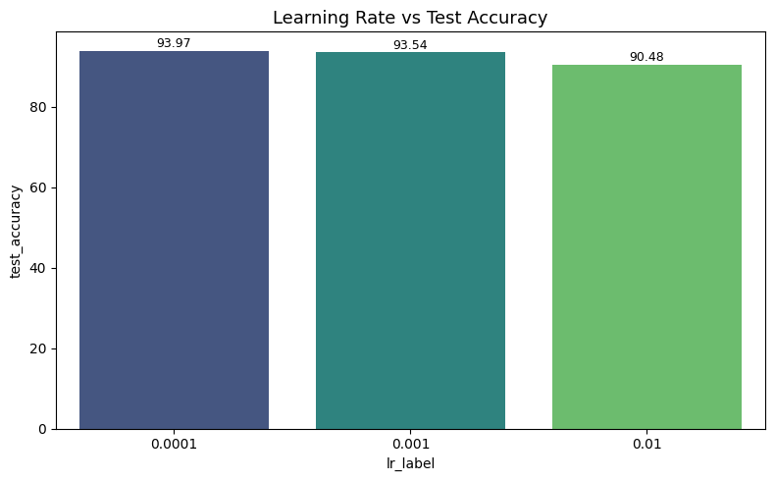
Figure 1: Test accuracy comparison across three learning rates.
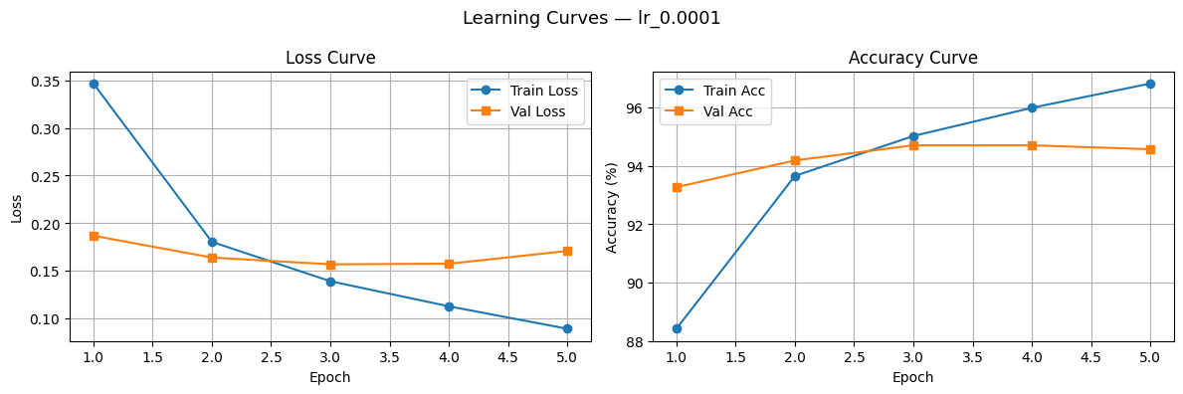
Figure 2: Training and validation learning curves for LR=0.0001, showing smooth convergence with a widening train-val accuracy gap indicative of mild overfitting.
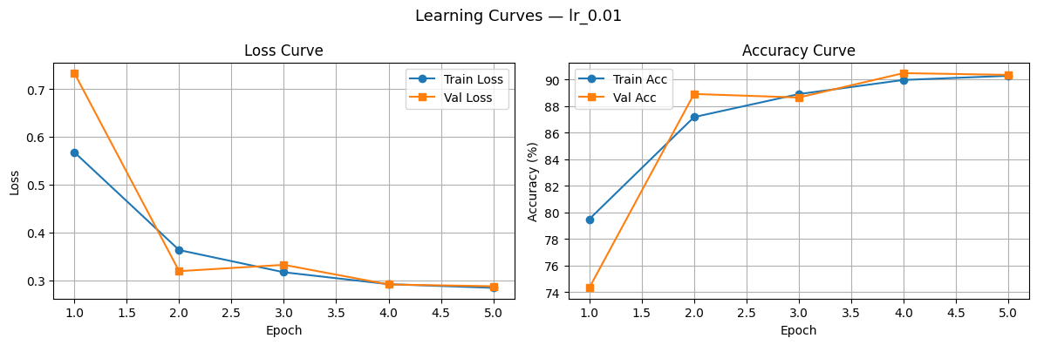
Figure 3: Learning curves for LR=0.01, showing volatile loss values and lower plateau accuracy, consistent with learning rate overshoot.

4.2 Study 2: Batch Size
Three batch sizes were compared over 5 epochs with the Adam optimizer at LR=0.001. The differences in test accuracy are marginal (less than 0.1%), though smaller batches required significantly more training time.

Experiment | Batch Size | Best Val Acc (%) | Test Accuracy (%) | Macro F1 (%) | Training Time (s)
bs_16 | 16 | 93.53 | 93.60 | 93.55 | 1061.13
bs_32 | 32 | 93.73 | 93.54 | 93.45 | 552.20
bs_64 | 64 | 93.83 | 93.57 | 93.55 | 362.66
Table 5: Batch size study results.

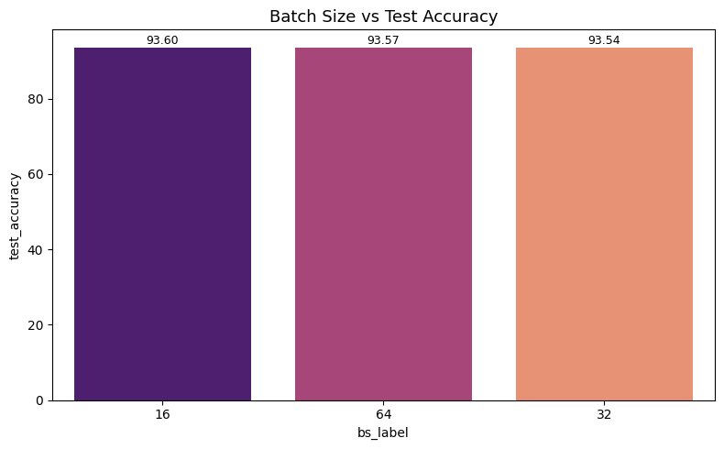
Figure 4: Test accuracy across batch sizes 16, 32, and 64.

4.3 Study 3: Optimizer
Adam, SGD with momentum (0.9), and RMSprop were compared at LR=0.001 over 5 epochs. Adam achieved the highest test accuracy. SGD showed a distinctly different convergence trajectory, starting from a higher initial loss but converging steadily.

Experiment | Optimizer | Best Val Acc (%) | Test Accuracy (%) | Macro F1 (%) | Training Time (s)
opt_Adam | Adam | 93.73 | 93.54 | 93.45 | 578.54
opt_RMSprop | RMSprop | 93.97 | 93.35 | 93.31 | 548.00
opt_SGD | SGD | 94.03 | 93.21 | 93.20 | 552.13
Table 6: Optimizer study results.

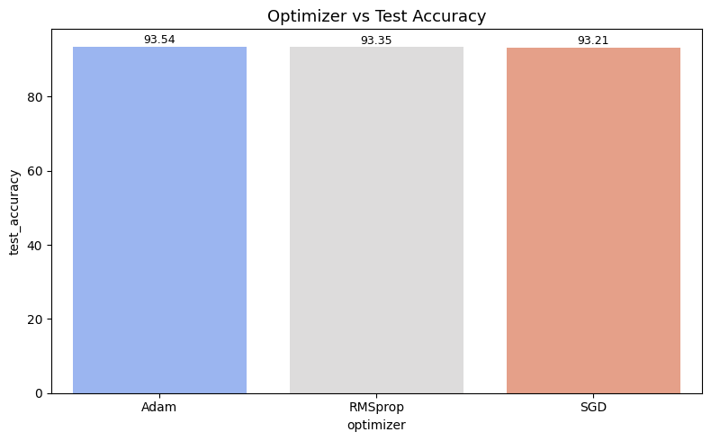
Figure 5: Test accuracy comparison across Adam, RMSprop, and SGD optimizers.
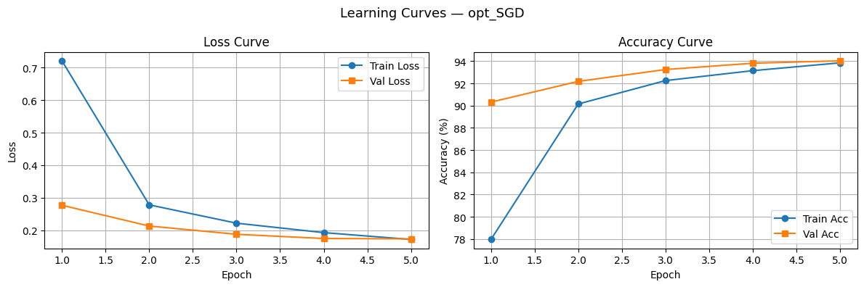
Figure 6: SGD shows a higher initial training loss (~0.72) compared to Adam (~0.33), reflecting its slower initial convergence without adaptive gradient scaling.

4.4 Study 4: Epoch Count
Three training durations (3, 5, and 8 epochs) were evaluated at the baseline configuration. Increasing epochs consistently improved performance, with 8 epochs achieving the highest test accuracy across all experiments in the entire study.

Experiment | Epochs | Best Val Acc (%) | Test Accuracy (%) | Macro F1 (%) | Training Time (s)
epochs_3 | 3 | 93.27 | 93.30 | 93.27 | 327.39
epochs_5 | 5 | 93.73 | 93.54 | 93.45 | 543.01
epochs_8 | 8 | 94.87 | 94.29 | 94.29 | 911.41
Table 7: Epoch count study results.
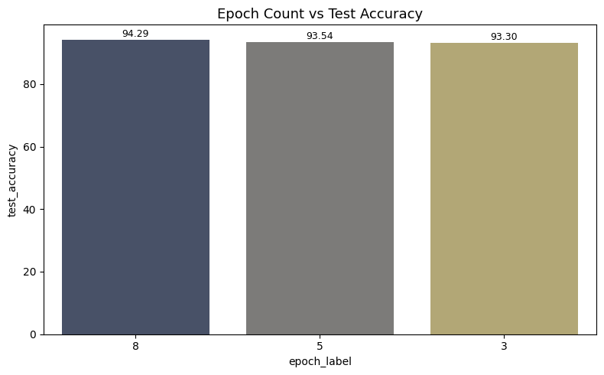
Figure 7: Test accuracy increases monotonically with epoch count from 3 to 8 epochs.
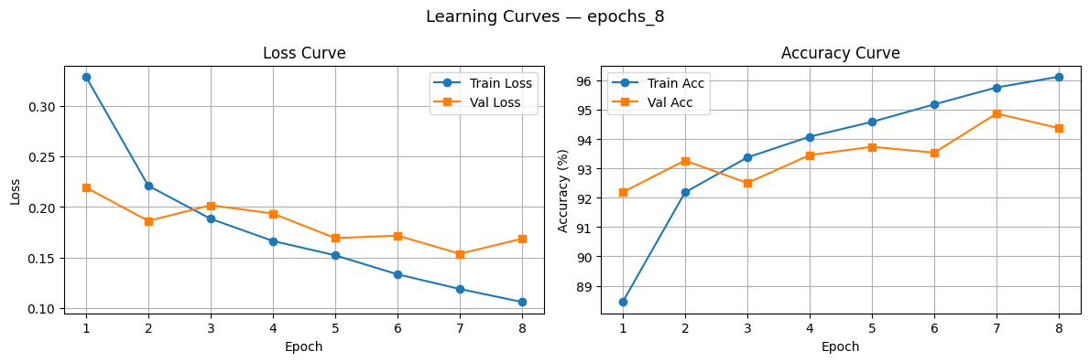
Figure 8: At 8 epochs, the training accuracy continues to improve while validation accuracy reaches ~94.87%, with no signs of overfitting within this training budget.

4.5 Study 5: Activation Function
Four activation functions (ReLU, LeakyReLU, GELU, SiLU) were tested in the classifier head at the baseline configuration. SiLU achieved the highest test accuracy and macro F1, outperforming ReLU by approximately 0.42 percentage points.
Experiment | Activation | Best Val Acc (%) | Test Accuracy (%) | Macro F1 (%) | Training Time (s)
act_SiLU | SiLU | 94.32 | 93.96 | 93.96 | 569.46
act_ReLU | ReLU | 93.73 | 93.54 | 93.45 | 563.56
act_GELU | GELU | 93.85 | 93.31 | 93.29 | 527.57
act_LeakyReLU | LeakyReLU | 93.83 | 93.29 | 93.25 | 544.81
Table 8: Activation function study results.
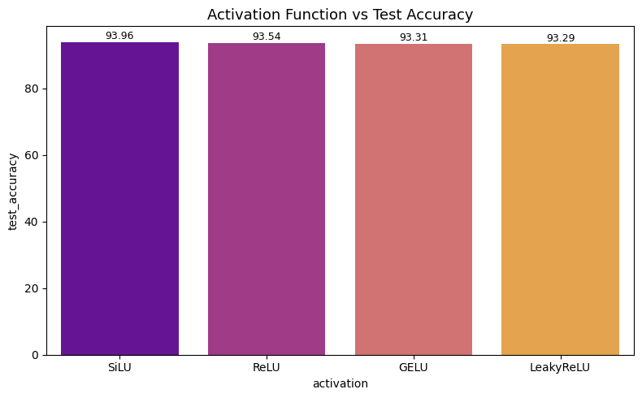
Figure 9: SiLU outperforms all other activation functions tested in the classifier head.
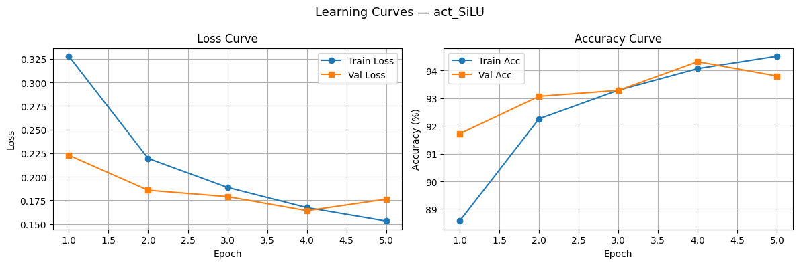
Figure 10: SiLU learning curves showing faster convergence and higher validation accuracy compared to ReLU.

4.6 Study 6: Padding Strategy
Three padding strategies applied before resizing 28×28 images to 224×224 were evaluated: no padding (direct resize), constant zero-padding of 6 pixels on each side, and reflect padding of 6 pixels. Constant padding achieved the highest test accuracy, though differences across all three strategies are small.
Experiment | Padding | Best Val Acc (%) | Test Accuracy (%) | Macro F1 (%) | Training Time (s)
pad_constant | Constant (zero) | 94.27 | 93.60 | 93.57 | 600.58
pad_reflect | Reflect | 93.43 | 93.59 | 93.55 | 595.57
pad_none | None | 93.73 | 93.54 | 93.45 | 809.40
Table 9: Padding strategy study results.
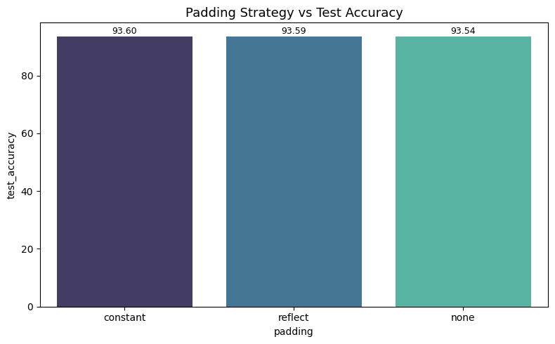
Figure 11: All three padding strategies achieve similar test accuracy, with constant padding marginally ahead.

4.7 Master Results: All Experiments Ranked
The table below consolidates all 19 experiments from the six studies, sorted by validation accuracy. The epochs_8 configuration (8 training epochs at baseline settings) achieved the highest test accuracy of 94.29% and is designated the overall best experiment.

Experiment | LR | BS | Opt | Act | Pad | Epochs | Val Acc (%) | Test Acc (%) | Macro F1 (%)
epochs_8 | 0.001 | 32 | Adam | ReLU | none | 8 | 94.87 | 94.29 | 94.29
lr_0.0001 | 0.0001 | 32 | Adam | ReLU | none | 5 | 94.70 | 93.97 | 94.02
act_SiLU | 0.001 | 32 | Adam | SiLU | none | 5 | 94.32 | 93.96 | 93.96
pad_constant | 0.001 | 32 | Adam | ReLU | constant | 5 | 94.27 | 93.60 | 93.57
bs_16 | 0.001 | 16 | Adam | ReLU | none | 5 | 93.53 | 93.60 | 93.55
bs_64 | 0.001 | 64 | Adam | ReLU | none | 5 | 93.83 | 93.57 | 93.55
pad_reflect | 0.001 | 32 | Adam | ReLU | reflect | 5 | 93.43 | 93.59 | 93.55
opt_SGD | 0.001 | 32 | SGD | ReLU | none | 5 | 94.03 | 93.21 | 93.20
opt_RMSprop | 0.001 | 32 | RMS | ReLU | none | 5 | 93.97 | 93.35 | 93.31
epochs_3 | 0.001 | 32 | Adam | ReLU | none | 3 | 93.27 | 93.30 | 93.27
lr_0.01 | 0.01 | 32 | Adam | ReLU | none | 5 | 90.47 | 90.48 | 90.27
Table 10: All 19 experiments sorted by validation accuracy.

5. Analysis and Insights

5.1 Learning Rate
Learning rate had the most pronounced effect among the five-epoch studies, with a gap of 3.49 percentage points between the best (LR=0.0001, 93.97%) and worst (LR=0.01, 90.48%) configurations. The LR=0.01 curve (Figure 3) shows volatile loss values and a higher validation loss plateau, consistent with gradient overshooting in the neighbourhood of the loss minimum. At LR=0.0001, the model converges more smoothly, and the training accuracy continues to improve across all five epochs, suggesting that with more epochs it could improve further. However, the training accuracy diverges from validation accuracy at epoch 5, indicating early-stage overfitting.
The LR=0.001 baseline sits between these extremes, converging reasonably but not achieving the smoothness of LR=0.0001. For transfer learning tasks where the backbone is frozen and only a small head is trained, a smaller learning rate generally reduces the risk of loss landscape instability, which explains why LR=0.0001 performs best within five epochs.

5.2 Batch Size
Batch size had the smallest impact on test accuracy among all hyperparameters studied, with a spread of only 0.06 percentage points between BS=16 (93.60%) and BS=32 (93.54%). This narrow margin suggests that the Fashion-MNIST task, combined with a frozen EfficientNet-B0 backbone, is largely insensitive to batch size variation within the tested range.
BS=64 converged faster per epoch (362 seconds vs 1061 seconds for BS=16) due to fewer weight update steps and better GPU utilization, achieving nearly identical test accuracy to the smaller batches. The slight accuracy advantage of BS=16 is consistent with the well-known effect of small-batch stochastic gradient descent providing implicit regularization through noisier gradient estimates, though the difference here is not practically significant.

5.3 Optimizer
Adam outperformed both RMSprop and SGD on test accuracy (93.54% vs 93.35% and 93.21% respectively). The most striking observation from this study is the SGD learning curve (Figure 6): SGD's initial training loss at epoch 1 was 0.72, compared to approximately 0.33 for Adam and 0.37 for RMSprop. This reflects the absence of adaptive gradient scaling in SGD; with a fixed learning rate of 0.001, it takes SGD significantly more iterations to overcome the initial slow convergence.
Despite this slow start, SGD's best validation accuracy of 94.03% actually exceeded Adam's 93.73% (Table 6), suggesting that SGD's more uniform gradient updates may generalize slightly better during validation. However, test accuracy tells a different story, with SGD trailing Adam by 0.33 points. The discrepancy between validation and test accuracy for SGD may reflect the noise in validation metrics across 6,000 images. Overall, Adam remains the preferred choice for transfer learning tasks with limited epochs.

5.4 Epoch Count
Epoch count was the single most impactful hyperparameter in this study, with 8 epochs (94.29%) outperforming 5 epochs (93.54%) by 0.75 percentage points and 3 epochs (93.30%) by 0.99 percentage points. The learning curve for epochs_8 (Figure 8) shows that the training accuracy continues to rise steadily across all eight epochs while validation accuracy reaches a peak of 94.87% at epoch 7, with no severe overfitting within this budget.
This result implies that the baseline of 5 epochs is insufficient for the model to reach its performance ceiling on this task, and that additional training epochs provide consistent returns. The monotonic improvement across 3→5→8 epochs also suggests that even higher epoch counts might yield further gains, provided a learning rate schedule or regularization mechanism is applied to prevent overfitting.

5.5 Activation Function
SiLU (Sigmoid-weighted Linear Unit, also known as Swish) achieved the highest test accuracy (93.96%) and macro F1 (93.96%), outperforming the ReLU baseline by 0.42 points. SiLU and GELU are both smooth, non-monotonic activation functions that have demonstrated advantages over ReLU in deep learning tasks, as they allow small negative values to propagate rather than zeroing them out completely.
The performance ordering (SiLU > ReLU > GELU > LeakyReLU) is somewhat unexpected, as GELU and LeakyReLU might be expected to outperform standard ReLU given their additional flexibility. However, since the activation is applied in a small two-layer head (only 256 hidden units), the differences between activation functions are likely small and may be influenced by random initialization effects. The consistent advantage of SiLU across both test accuracy and macro F1 suggests a genuine benefit in this setting.

5.6 Padding Strategy
Padding strategy had the smallest absolute impact on test accuracy among all studies, with a spread of only 0.06 percentage points (constant: 93.60%, reflect: 93.59%, none: 93.54%). This is expected, since the dominant transformation in the preprocessing pipeline is resizing from 28×28 to 224×224 (an 8× magnification), which renders the additional 6-pixel padding marginal in effect.
The constant zero-padding approach produces a black border around the image before resizing, which slightly reduces the effective content area but may help the model learn to discount border regions. Reflect padding mirrors edge pixels and introduces a degree of spatial continuity at borders. Neither strategy provides a meaningful advantage over direct resizing for this dataset, and the no-padding baseline remains competitive. For datasets with finer spatial structure, padding strategy may matter more.

5.7 Best Model: Confusion Matrix Analysis
The best-performing configuration (epochs_8) achieved a test accuracy of 94.29% and macro F1 of 94.29% on the 10,000-sample Fashion-MNIST test set. The confusion matrix (Figure 12) reveals the following class-level patterns:
- Trouser (99.0%), Bag (99.2%), and Ankle Boot (97.9%) are classified with the highest per-class accuracy, reflecting their visually distinctive shapes.
- Shirt (82.2%) is the most confused class, with 89 samples misclassified as T-shirt/top and 44 as Pullover, reflecting the visual similarity among top garments.
- Coat (91.3%) shows confusion with Pullover and Shirt, both structurally similar upper-body garments.
- Sandal vs Ankle Boot confusion (13 samples) is the primary footwear confusion, expected given their shared category.

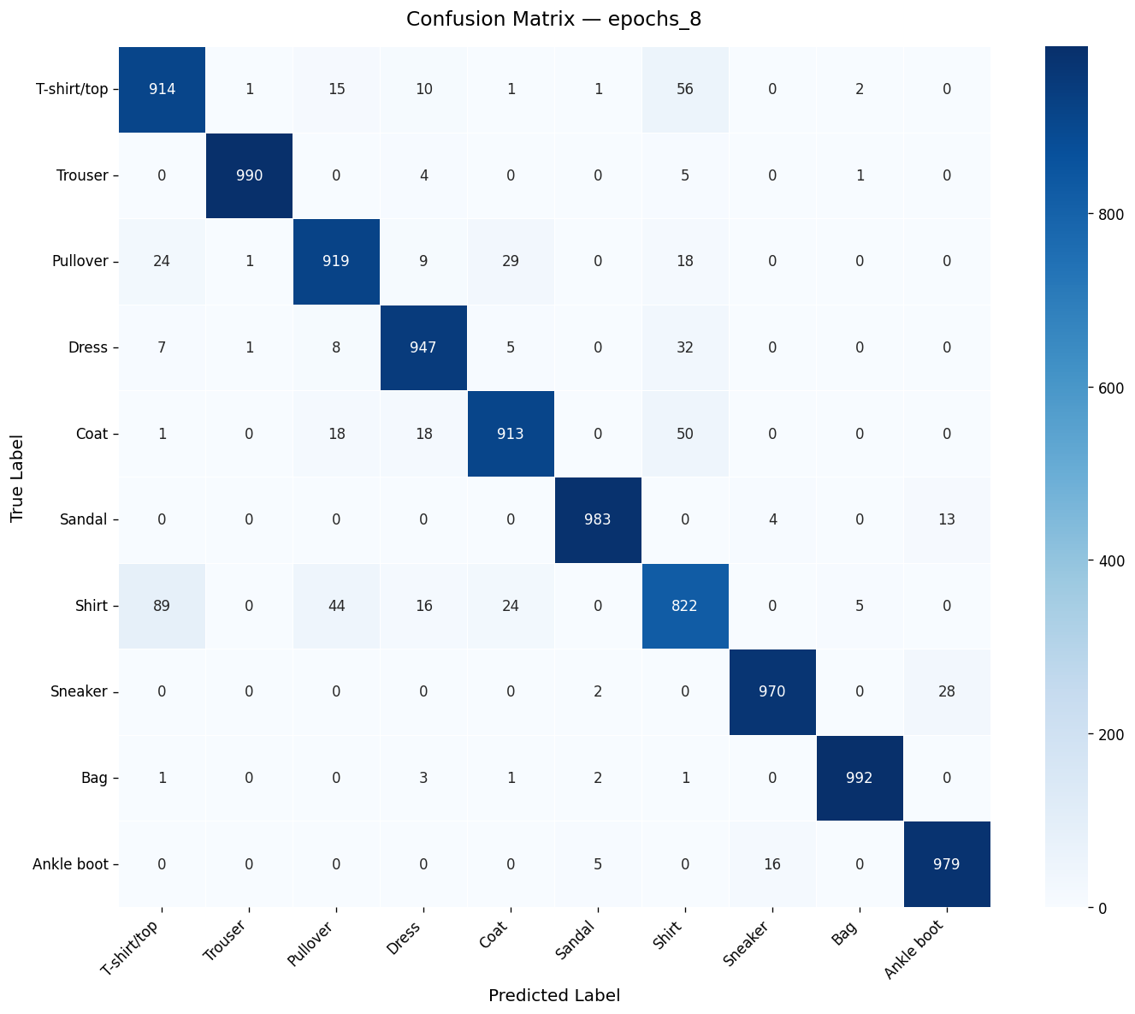
Figure 12: Confusion matrix for the best model (epochs_8). Rows are true labels; columns are predicted labels. Shirt and Coat exhibit the most inter-class confusion.

6. Summary and Conclusion

6.1 Summary of Findings

Hyperparameter | Best Value | Test Accuracy (%) | Macro F1 (%) | Key Observation
Learning Rate | 0.0001 | 93.97 | 94.02 | LR=0.01 causes instability; smaller LR converges more stably
Batch Size | 16 | 93.60 | 93.55 | Minimal impact; BS=64 offers best compute efficiency
Optimizer | Adam | 93.54 | 93.45 | Adam converges faster; SGD achieves comparable val accuracy
Epoch Count | 8 | 94.29 | 94.29 | Largest gain; model not saturated at 5 epochs
Activation Fn. | SiLU | 93.96 | 93.96 | SiLU consistently outperforms ReLU by ~0.42 points
Padding Strategy | Constant | 93.60 | 93.57 | Negligible effect; all strategies perform similarly
Table 11: Final summary of best hyperparameter values and key observations.

The overall best experiment was epochs_8 (8 training epochs at the baseline Adam optimizer, LR=0.001, batch size 32, ReLU activation, no padding), achieving a test accuracy of 94.29% and macro F1 of 94.29% on Fashion-MNIST.

6.2 Conclusions
This study demonstrates that even with a frozen pretrained backbone, hyperparameter selection has a meaningful impact on classification performance. The most important findings are:
- Epoch count has the largest single impact on performance within the tested range. Increasing from 5 to 8 epochs yields a 0.75-point accuracy gain with no signs of overfitting, suggesting that transfer learning tasks benefit from longer training when the backbone is frozen and only a small head is being optimized.
- Learning rate selection is critical. An overly large learning rate (0.01) degrades performance by approximately 3.5 percentage points compared to the optimal value (0.0001), while a moderately small rate (0.001) provides a reasonable but suboptimal trade-off between convergence speed and final accuracy.
- Activation function choice in the classifier head has a moderate but consistent effect. SiLU outperformed ReLU across all metrics, suggesting that smooth activation functions with non-zero gradients for negative inputs offer a practical advantage in small classification heads.
- Batch size and padding strategy had negligible effects on accuracy in this experimental setting. Batch size affects training efficiency significantly, with BS=64 being approximately 3× faster than BS=16 for essentially the same accuracy.
- Adam is the most robust optimizer choice for this type of transfer learning task, providing the fastest convergence and the highest test accuracy within a fixed epoch budget compared to SGD and RMSprop.

These findings provide practical guidance for configuring pretrained model fine-tuning pipelines: prioritize sufficient training epochs and a well-tuned learning rate before investing compute in batch size optimization or exotic activation functions. The results also confirm that EfficientNet-B0, even with a fully frozen backbone, is a strong baseline for 10-class image classification tasks, achieving over 93% accuracy on Fashion-MNIST with minimal hyperparameter tuning.

